CASE STUDY 23 Student Timetable Conflict Detection
1. Problem Statement
Validate a proposed timetable represented with course, day, start time, end time, and room, detecting overlapping classes and room clashes.
2. Objectives
Represent schedule entries using tuples.
Compare time intervals using loops.
Detect student timetable and room conflicts.
3. Assumptions
Times are entered as integer hours in 24-hour format (for example, 9 and 11).
A class occupies the interval from start inclusive to end exclusive.
All entries represent the same student group unless noted otherwise.
4. Algorithm
1. Read the number of classes.
2. For each class, read course, day, start, end, and room.
3. Validate that start is before end and times are within 0–23.
4. Compare each pair of valid classes on the same day.
5. If their time intervals overlap, report a student conflict; if the room is also the same, report a room conflict.
6. Print the conflict report.
5. Flowchart
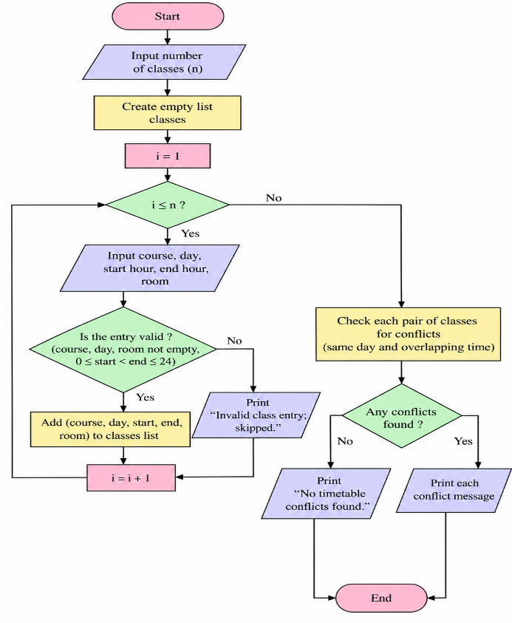
6. Pseudocode
START
INPUT n
READ each class as tuple (course, day, start, end, room)
FOR i from 0 to n-1: FOR j from i+1 to n-1
IF same day AND start_i < end_j AND start_j < end_i: report timetable conflict
IF conflict AND same room: report room clash
PRINT report
END
7. Test Cases
Test | Input / Scenario | Expected result
1 | Math Monday 9-11 Room A; Python Monday 10-12 Room B | Overlapping classes reported
2 | Math Monday 9-10 Room A; Python Monday 10-11 Room A | No conflict; intervals touch but do not overlap
3 | Math Monday 9-11 Room A; Lab Monday 10-12 Room A | Student conflict and room clash
8. Output Screenshot
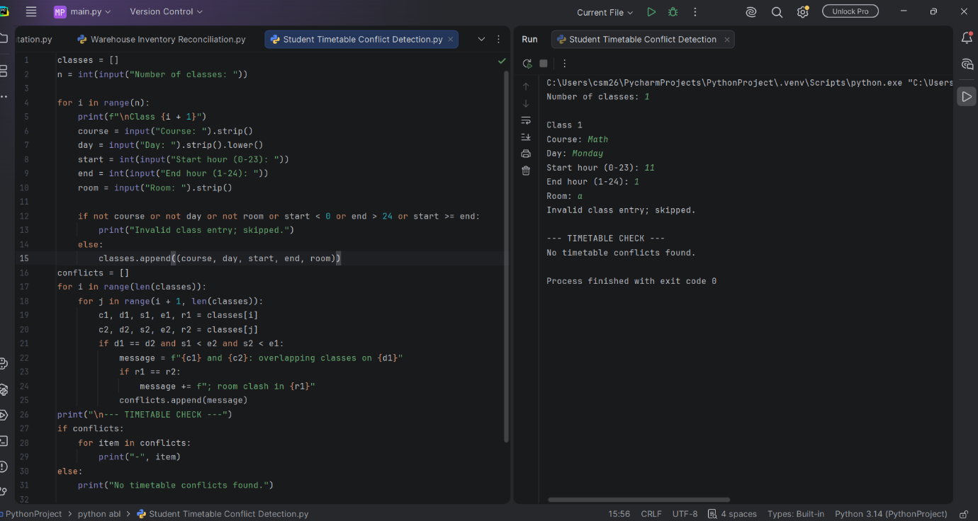
9. Conclusion
The program uses tuples and pairwise interval comparisons to detect overlapping classes and room clashes.

